Administrator management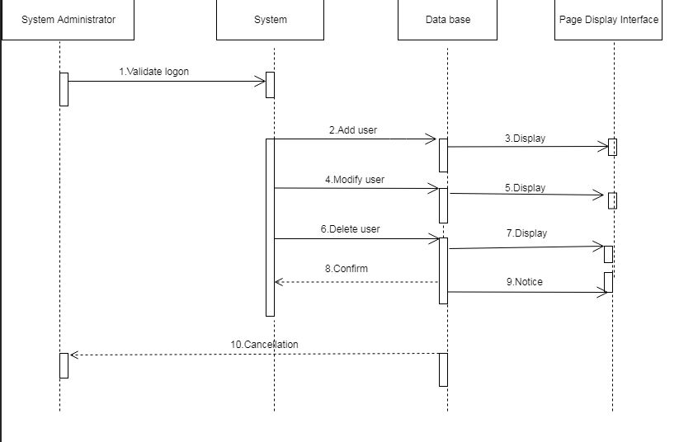

Recruiter interview and resume management

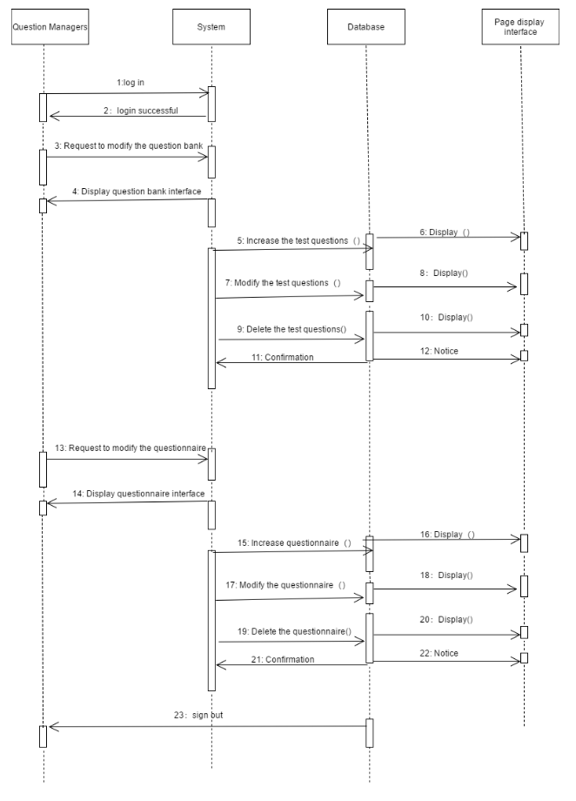

## Plan of Work

As an application system of human resource management, the online recruitment system should be aimed at all persons concerned with recruitment management. After analysis, the system participants are: unit leaders, heads of departments, human resources management departments, recruitment managers, candidates, system administrators.

The functional requirements of each type of participants are as follows: the leader of the unit decides the final list of selected personnel, and the head of each part of the unit submits the human resources planning plan of the department, and submits the human resources planning plan of the department.

From the point of view of system design, the system needs to achieve the following objectives:

1. Good scalability. With the continuous development of enterprises and the increasing demand of recruitment business, the functions of the system will inevitably continue to expand. Therefore, it is necessary to design interfaces and specifications in order to flexibly increase and decrease functional modules and play a synergistic role for enterprise informatization.

2. The organization and flexibility of the structural process. The diversity and variability of recruitment activities require that the system structure process can be handled flexibly. The concurrent situation of multi-process requires that the system can standardize the recruitment process, so that the structure process is both orderly and flexible.

3. Centralized management. To achieve the unified management of the head office and the companies differentiated from each other logically and physically, it is necessary to transfer data sharing to application centralization.

4. Friendly user interface. User interface needs to be humanized, clear and reasonable layout, convenient operation and business processing. As far as possible, all functional operations are concentrated in the main interface. Each functional interface requires a unified style, which is convenient for users to cite one thing from the other, and can familiarize themselves with the system more quickly and improve work efficiency.

The overall design includes: database design and code design, input and output design, physical configuration design, security design. We are working hard on database design and code design. We are not ready for input-output design and material configuration design. We ensure the security design by data integrity constraints after the completion of the plan.

## Breakdown of Responsibilities

We have four people in our team. Lewis is the manager of every project and plan. Wade is responsible for debugging code, Rick is responsible for calling instances, Troy is responsible for system page design.

|  |  |  |  |
| --- | --- | --- | --- |
| Phase | Requirement Trace | Guidance | Requirement |
| URS | URS-01 | Set your requirement | All entity users (tourists, job seekers, recruiters, managers,) can log in to this online recruitment system. Attributes of entity classes can also be viewed in this system, such as job seekers'personal information and resumes, recruiters' recruitment information, corporate information and resumes. |
| FS | FS-01 | Requirement is described in the form of its functionality | All entity classes should be managed by system administrators |
| DS | DS-01 | Detailed description of how the functionality will be fulfilled | All entity classes can be logged on to this online recruitment system. |
| DR | DR-01 | Verify that your requirement has been accommodated in the design documents. Verify that objects of entities is included in the functional and design documents | Verify (looking at the specifications) that it is able tocomply with the requirements for the syetem. Verify that it is connected to an administer in the functional &design documents. |
| FAT | FAT-01 | N/A (as this would is built directly on site) | N/A (If this was built off site, verify that it is physically present, properly installed and connected) |
| SAT | SAT-01 | The supplier must verify that they have supplied you with an object that can fulfil your requirements (physical presence/installati on and functionality) | 1.Can administrators manage all users?  2.Can entity users log on to the system?  3.  Can users publish their own related properties? |
| IQ | IQ-01 | This is where you ensure that the installation is correct - refer to vendor documents if possible.Also check that the object has been entered into your systems maintenance schedule | Verify that the installation of the instrument and its connections are installed correctly |
| OQ | OQ-01 | Verify the functionality of the object. If possible, refer to vendor test documents here as well. | Test whether the user instance can log on to the online recruitment system, whether the system interface class can be displayed normally after successful login, and whether the user functional experience is good? |
| PQ | PQ-01 | Checking for seasonal variationsor long term functionality (in this case). A PQ is designed to prove that an object works taking the whole picture into account. | Through the management of administrators, verify whether all instances can use the functions of the system in a long period of time? |

